Jerry Olds

1001533643

IE-4378-001

9/24/2019

Mission/System Requirements and Sub-System Selection

Mission: The vehicle shall navigate the obstacle course while staying within the boundaries and not colliding with any of the obstacles.

Requirements

1.0 The system shall take no human input (other than e-stop) while in autonomous mode  
2.0 The system shall have e-stop functionality  
 2.1 The system shall come to a complete stop if the wireless e-stop button is pressed  
 2.2 The system shall come to a complete stop if the mechanical e-stop button is pressed  
3.0 The system will be propelled by wheels  
4.0 The system shall meet dimension requirements  
 4.1 The system will be at least 3 feet long and at most 7 feet long  
 4.2 The system will be at least 2 feet wide and at most 4 feet long  
 4.3 The system shall not exceed a height of 6 feet  
5.0 Vehicle power must be generated on board  
6.0 The system shall meet speed requirements  
 6.1 The system shall have an average speed of 1 mph upon completion of the course  
 6.2 The system shall not exceed a speed of 5 mph  
7.0 The system shall meet safety light requirements  
 7.1 The system’s safety light shall display a solid green light when powered on  
 7.2 The system’s safety light shall display a blinking green light when in autonomous mode  
8.0 The system shall carry a 20 pound, 18” x 8” x 8” payload while in operation  
9.0 The system shall meet environmental requirements  
 9.1 The system shall be able to operate in a grassy area  
 9.2 The system shall be able to use ramps (natural or artificial) with gradients not exceeding 15%  
 9.3 The system shall be able to operate in light rain or drizzle  
10.0 The system shall be started by a one touch motion (pressing a button, left mouse click,   
 pressing the enter key on a keyboard, flipping a switch, lifting e-stop, etc.)

Subsystems

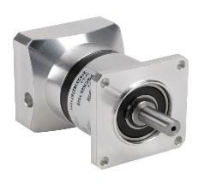

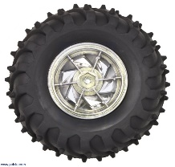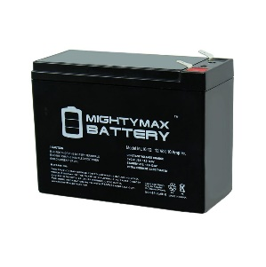

Wheels

Motors

Batteries

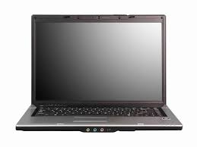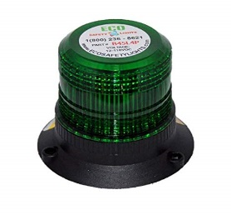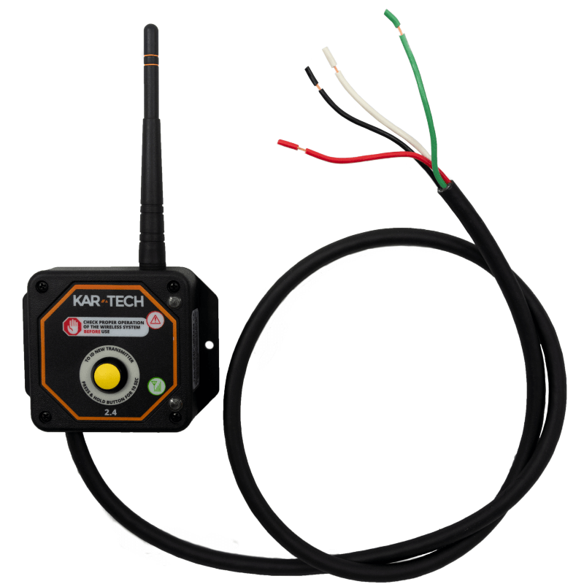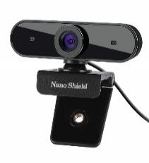

Sensors

Camera

Laptop

Safety Light

Wireless E-stop Antenna